Follow the exercises below.

Open Powerpoint and Create a new blank presentation

Add a title and sub title. Eg ‘earth day’
Add a new slide with title and content, then add some information as bullet points
70% of the Earth’s surface is covered in water, Earth is mostly iron, oxygen and silicon, The Earth’s Atmosphere Extends to a Distance of 10,000 km, The Earth’s Molten Iron Core Creates a Magnetic Field, It takes 23 hours, 56 minutes and 4 seconds for the Earth to rotate once completely.
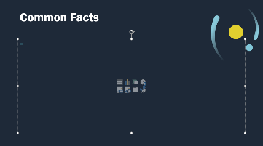
Highlight the last bullet point in yellow
